CommGap News Release
International Language Services

FOR IMMEDIATE RELEASE CONTACT: Paul Helms
April 23, 2019 +1-801-944-4049
sam@commgap.com

CommGap CEO Speaks to Snow College Students

EPHRAIM, Utah – April 20, 2019 – Last weekend CEO Lelani Craig was invited to Snow College to speak to students interested in entrepreneurship and global business. Lelani spent the day with Russ Tanner (Entrepreneurship Center Director at Snow College) and the students in his program. “I love speaking and sharing my experiences as an entrepreneur with students,” she said, “Much was shared, and much was learned.” 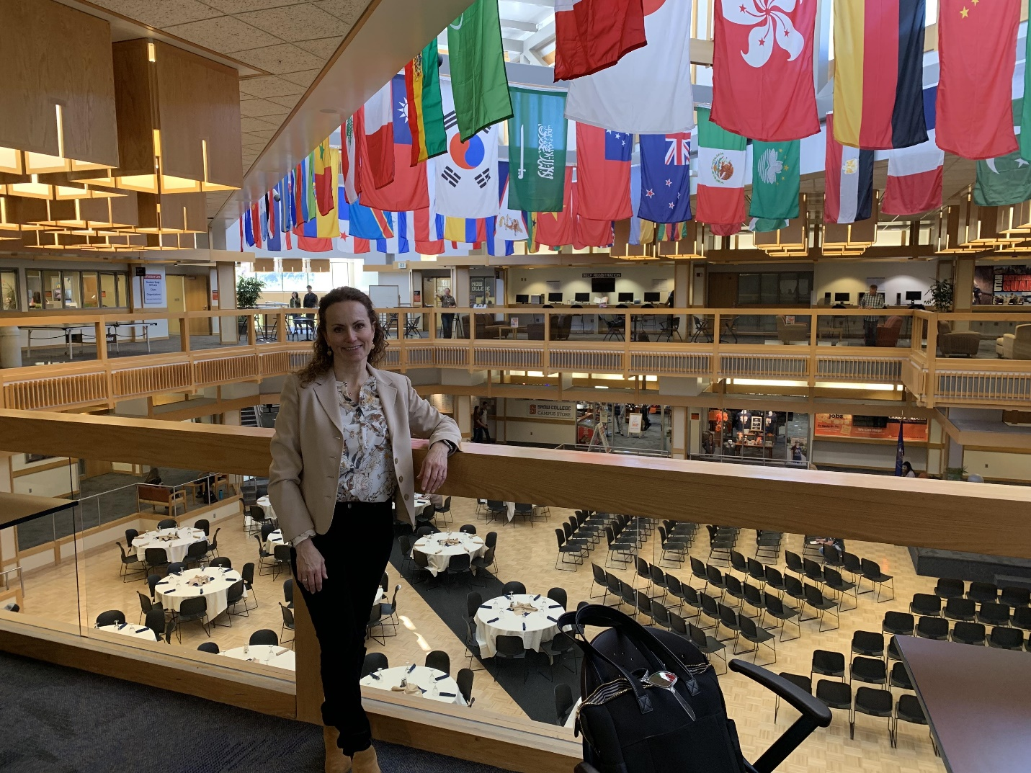
CommGap International Language Services is a company which provides a variety of high-quality language services, including interpretation, multimedia translation, and software and exam localization. Located in Salt Lake City, Utah, CommGap is a woman-owned, minority-owned small business that works exclusively with linguists who are experienced and certified in their field.

For more information, visit our website at: www.commgap.com.

